GitHub instructions:

In these instructions we assume people are using github through Rstudio. You might also use a dedicated GitHub desktop software and it would be pretty similar. For advanced users you could use the console.

1. Clone the repository:
   1. In Rstudio choose “File” -> “New project” -> “Version control” -> “Git”.
2. Add the repository URL:
   1. In Rstudio copy and paste the following in the Repository URL field:
      1. <https://github.com/ices-eg/wk_WKSEALS-2020.git>
   2. If you want to you can change the folder name where it is stored and also the location on your disk.
   3. Select “Create project”.

The project has now been cloned to your local machine and a new Rstudio project has been created. The repository contains the following folders:

* Data
* Documents
* Models
* Scripts

You can see this from the file browser in Rstudio (and also in file explorer if you browse to the folder you have stored the project in on your computer).

Notice a new panel has now appeared in Rstudio (top right in default settings), and it is called “Git”.

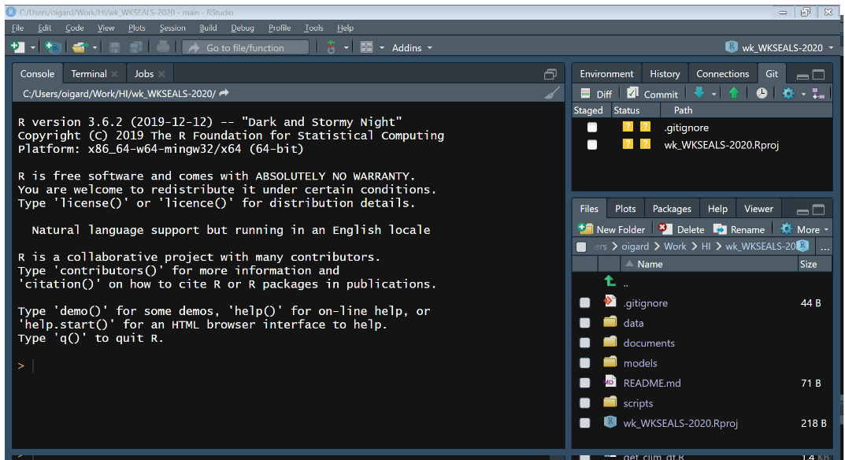

There are some new buttons. The main ones are “Commit”, “Pull (Blue arrow)” and “Push (Green arrow)”.

Next you need to add your model to the repository.

1. Always check that you have the latest version of the repository before you start doing any changes in order to avoid conflicts. Do this by pressing “Pull” and if you are up to date it will say “Already up to date”. Then you can start modifying the repository by adding, deleting and/or editing files.
2. To add your model you could use whatever file browser you prefer.
   1. If you are using File explorer go to the “Models folder”.
   2. Create a new folder for your model. We have decided to separate the different models with the nationality, so for e.g., Norway we have a folder called “Norway”.
   3. Copy your model to the new folder.
   4. Press “Commit”. Provide a short message of what you have done and “tick” the new files added.  
        
      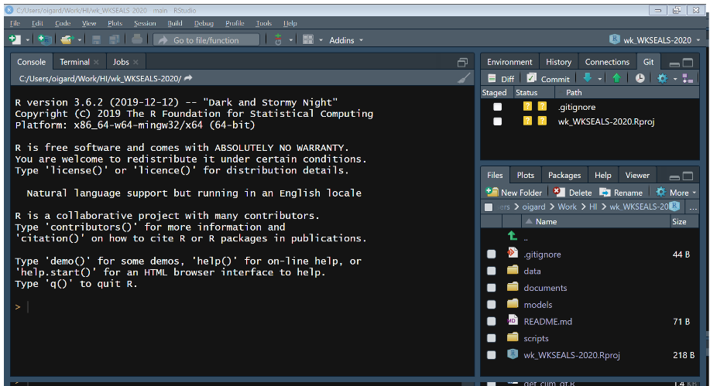  
        
      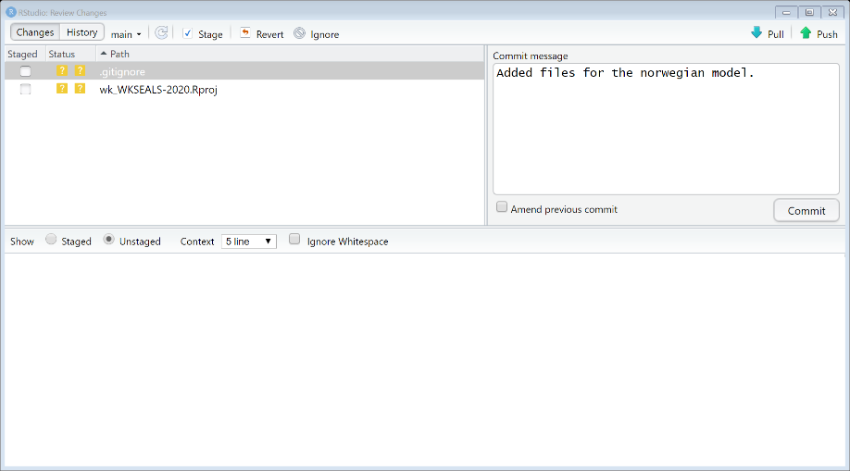
   5. Press “Push” and your model will be uploaded to the repository. You can confirm this by going to the GitHub website and to the repository there and check the “Models” folder.  
        
      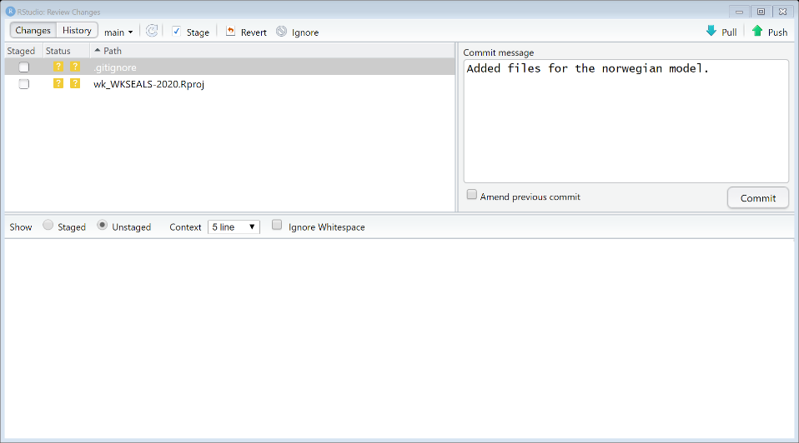
3. Add data to the repository in a similar way.
   1. Create a new folder in the “data” folder for your data and copy your data into that folder.
   2. Press “Commit” and provide a short message. Select the new files added.
   3. Press “Push” and the data will be uploaded to the repository.

To avoid conflicts it is **very important** that we always check that we have the latest version of the repository (by pulling) **before** we do any changes. Also, for every change we do, use “Commit” and then “Push”. If people are having problems and do not follow these instructions, we might get a lot of conflicts which need to be resolved and that could be very time consuming. There is a way to avoid this by everyone using their own branch instead of everyone pushing to the master branch, but this is a bit more technical so we would like to avoid that for now. If we all follow this simple routine it should be very smooth, and we should not have any problems 😊